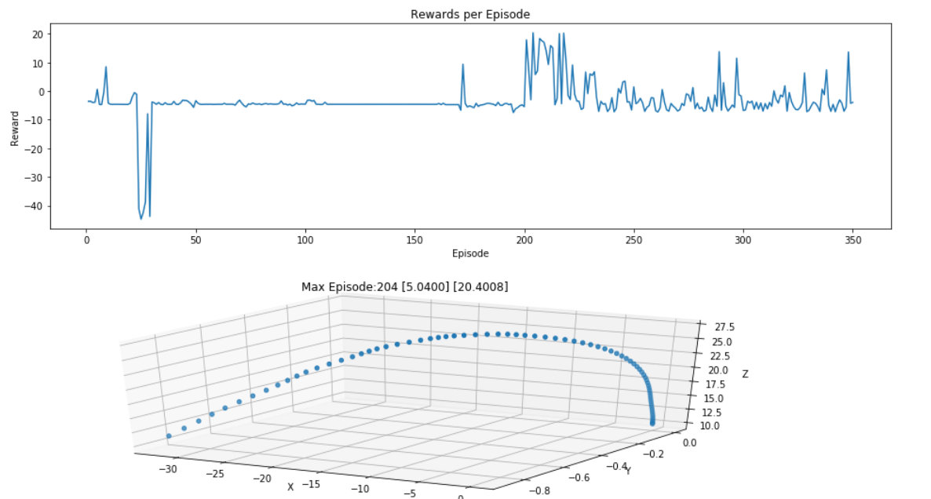

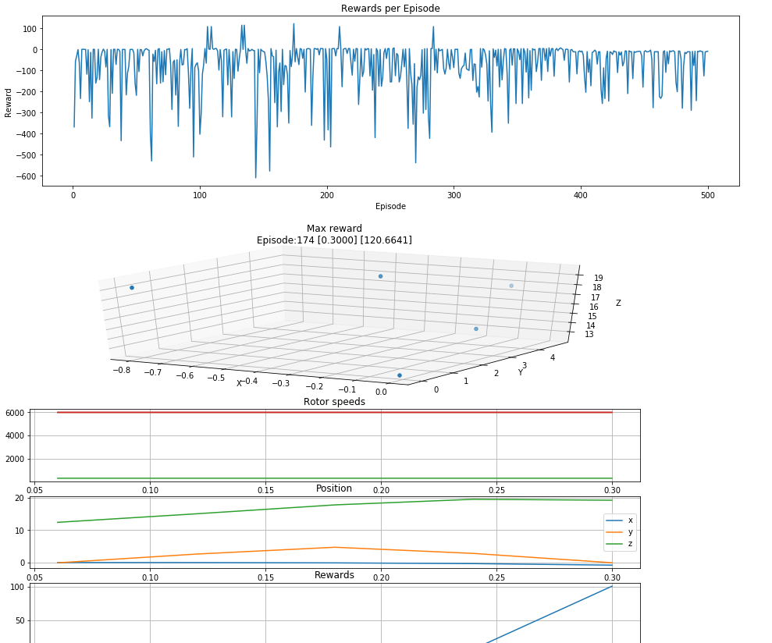
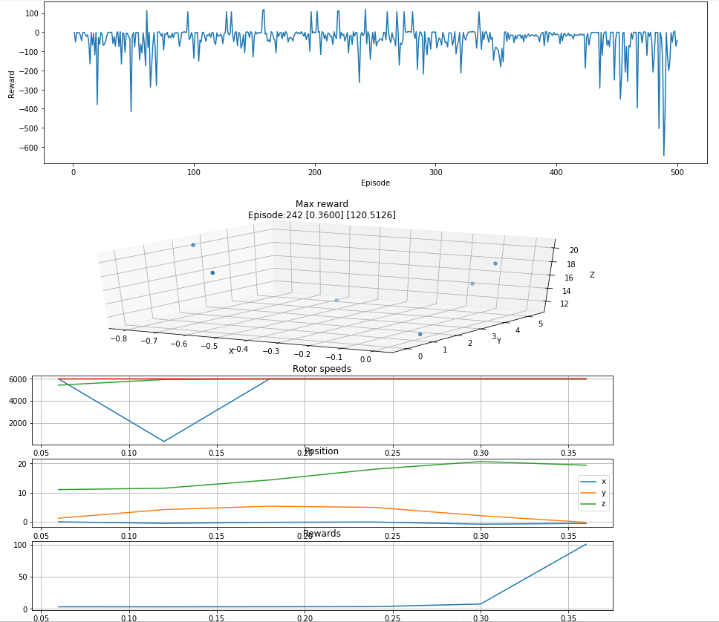
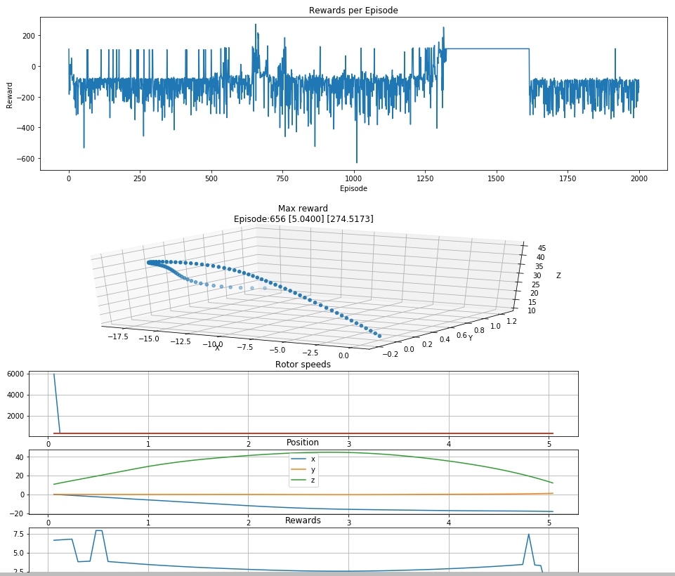
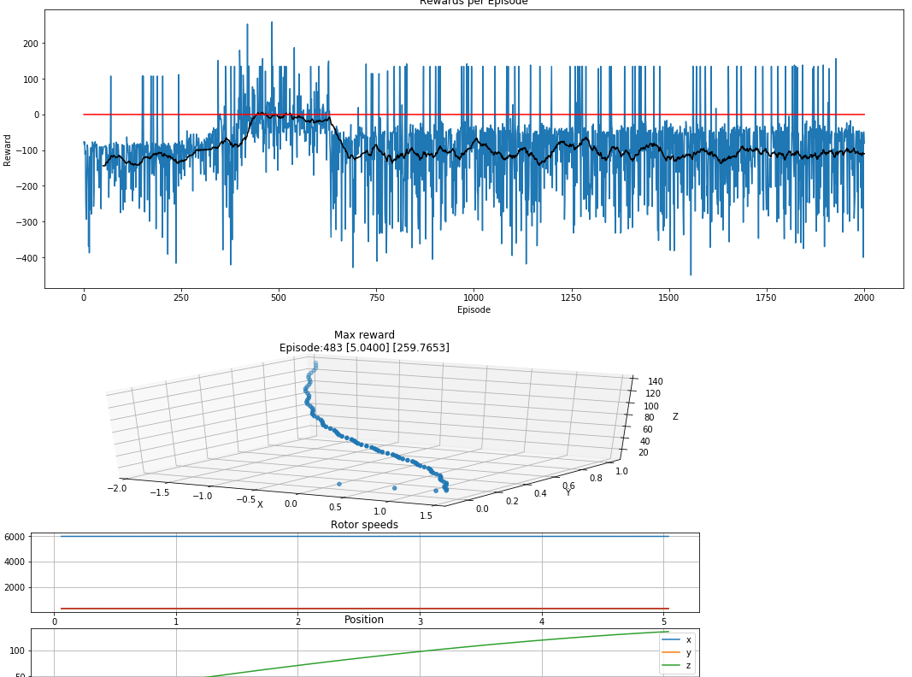

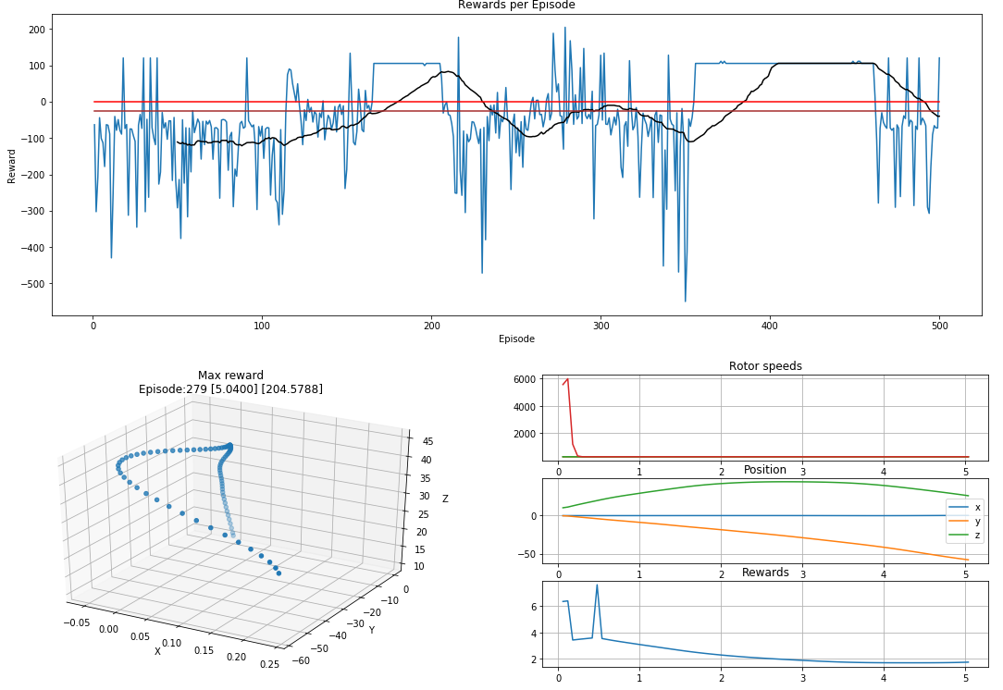

xyz_w = [.3, .3, .4]
reward weights = [.5, 1., .75, -1]
gamma = 1.
tau = 0.007

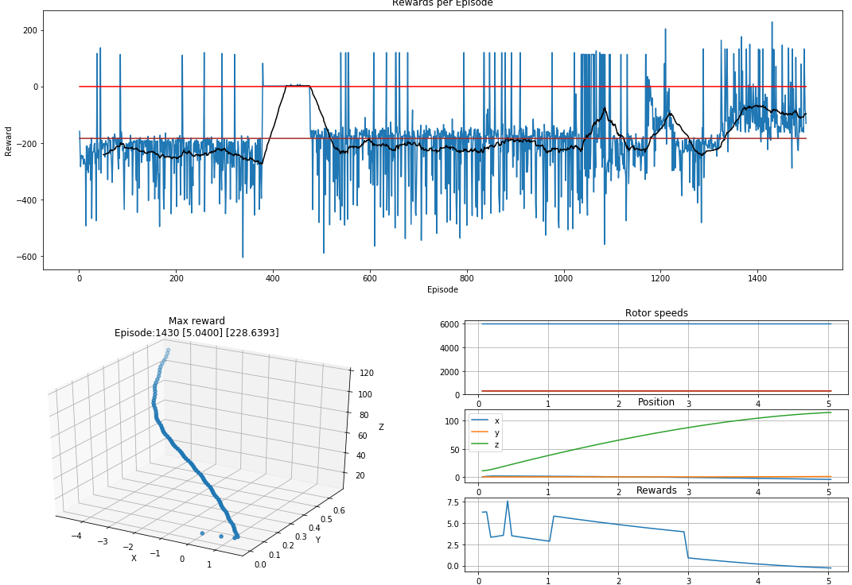

xyz_w = [.3, .3, .4]
reward weights = [.5, 1., .65, -1]
gamma = 1.
tau = 0.015

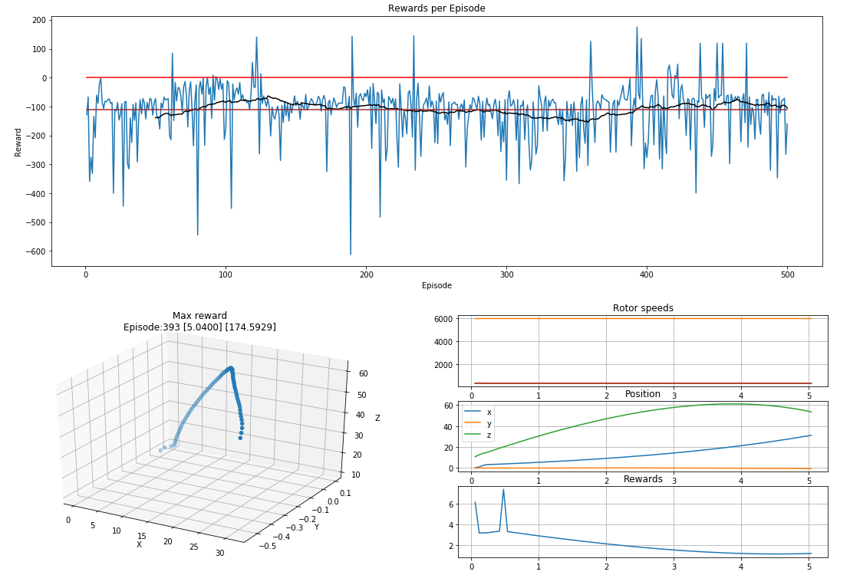

xyz_w = [.3, .3, .4]
reward weights = [.5, 1., .5, -1]
gamma = 0.97.
tau = 0.007

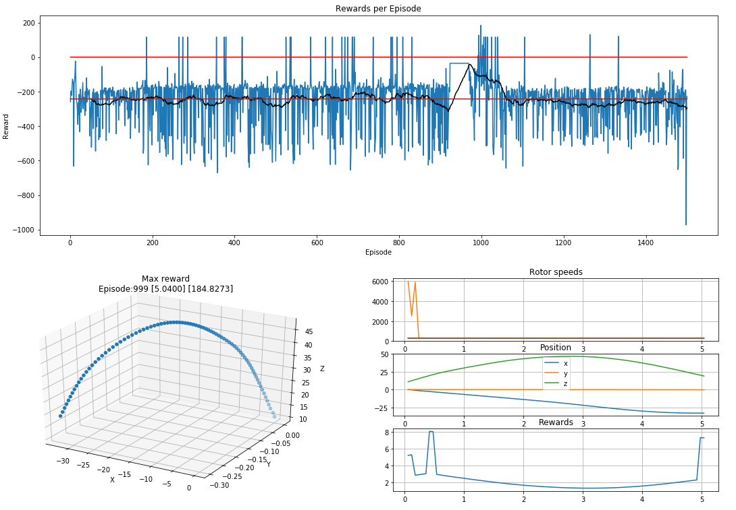

xyz_w = [.25, .25, .5]
reward weights = [.5, 1., .65, -1]
gamma = 1
tau = 0.015

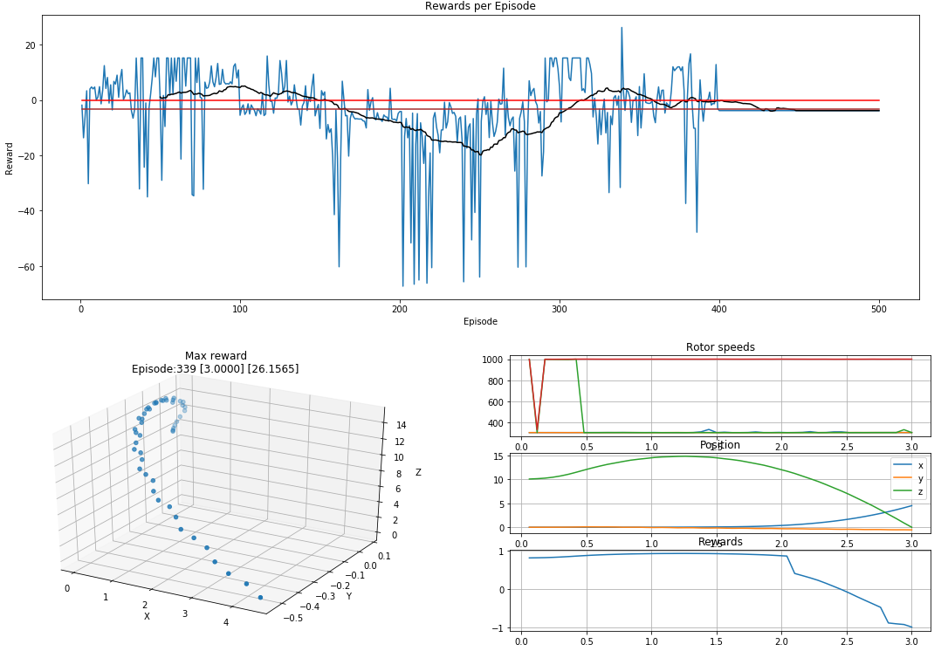

self.exploration_mu = 0
self.exploration_theta = 0.15
self.exploration_sigma = 0.2

self.gamma = 1 #discount factor
self.tau = 0.018 #for soft update of target parameters

self.action_low = 300
self.action_high = 1000

weights = [.15, .25, .6, -1]

reward = np.tanh(np.dot(weights,[appr_reward, pos_reward, time_reward, crash_penalty]))
